DigiRAMP strategy 2015

A Content Delivery Network for Music

Integrate Rights and Media with Administration

Cut costs by Automation and Pay stakeholders in real-time

Promote Artists and Content directly to consumers



Table of content

Background 5

Business model 7

Services 7

Third party integration 7

Social integration 8

Content provider segments 8

Professional creators 8

Aspirational artists 8

Bands 9

Indie labels 9

Info graphics 10

Goals 12

Content Delivery for Pre-Cleared Music 12

Integrate Rights, and Media with Administration 12

Cut costs by Automation and real-time micro transactions 12

Promote Artists and Content directly to consumers 12

Roadmap / Strategy 13

Users and Content 13

Legal protection 13

Technology readiness 13

Production and Creation 14

Publishing and Rights owners 15

Universal Music Group 15

Distribution 16

Distribution Case studies 17

Nacional Records 17

Infinity cat 17

Loudr 18

Streaming services 18

Spodify 2014 18

Pandora Media 18

Apple Music 19

Sound cloud 20

# Background

Most revenue for usage of music comes from:

* Free usage of music as an ad driver.
* Streaming.
* Licensing.
* Public usage
* Sales to consumers

This revenue has to feed an entire food channel.

Here are some of the players:

* Streaming services
* Web shops
* Distribution
* Publishers
* Performance Rights Organizations
* Licensors
* Labels
* Production
* Artists
* Writers
* Composers

The interaction between the parties in the food chain is regulated by laws and a traditional praxis and leaves only a fraction of the income to the creators

Entering the digital age this entire setup in the industry is challenged

* One person and a computer can do entire productions
* The job performed by the publishing companies is down to only taking a cut of the pie
* The amount of music produced is going up
* The payment for usage pr. song is going down
* Streaming is paying next to nothing
* Ads generates the income on social media but is rarely accounted for

While the creative strive to get

* Exposure
* Respect
* Fame
* An income

Money is less important but a part of the recognition and a feeling of not getting ripped off by big companies, despite that most artists has no choice but to share their work on social media for free.

People still pays for music but the revenue rarely reaches the creative because:

* Is held by the channel, only when a threshold is reached the money is paid.
* Artists has to claim their money for usage of their music as an ad driver
* The price one playback on a streaming services is close to nothing
* There is to many parties taking a rake
* There is more music produced than ever so the individual works gets less exposure
* There is no transparency
* Revenue streams are scattered over to many places

Only the licensing marked seems unaffected of the changes but it requires

* A Label
* A publisher
* A lot of legal documents
* Administration
* Access to opportunities

For most creative this is simply not something they know about and if they did the expenses and affords would not be worth the work.

Until now!

Using new technology it's possible to cut the costs for the food chain down to a minimum and let the revenue flow directly to the creators in real-time.

DigiRAMP automatically generates

* A publisher
* A label
* All the legal documents required in the traditional setup
* A complete administration system that automatically streams the revenue directly to the creators bank accounts in real-time

This way

* No rights are violated.
* The costs for the traditional channel are brought down.
* Administration is automated
* There is transparency
* All parties gets paid

# Business model

Creating an account on DigiRAMP is free.

There is a fee on all transactions based on the payment gateway plus a DigiRAMP fee

* Stripe takes 30 cent + 2.9% on credit card transactions
* DigiRAMP takes 10 cent + 1.1% on credit card transactions minimum 1 cent
* DigiRAMP takes

There is a limit on free accounts when it comes to storage and transactions

As a part of the building value active users are evaluated as 16 USD each. This will convert on investments and on an exit.

B2B as a Delivery network DigiRAMP can provide cleared music to hardware vendors’ game developers and external streaming services app developer true an API

# Services

DigiRAMP offers a range of services and tools for music creators.

* Promotional tools
* Collaborations tools
* Administration tools
* Sales tools
* Legal framework
* Social interaction

For third party DigiRAMP offers an API with access to all features

* Promotional tools
* Collaborations tools
* Administration tools
* Sales tools
* Legal framework
* Social interaction

# Third party integration

* Garage band
* VST
* RTAS
* AUDIO Units
* Hardware

Easy access to upload/download/stream audio files from third party products

# Social integration

* Facebook.
* Twitter.
* LinkedIn.
* Google+
* Email

A tight integration with social networks lets creators promote their content among fans

# Content provider segments

Described in general

## Professional creators

* Have a lifetime of produced music. Up to 200 songs.
* Many contributors on the productions
* Overall high quality on the music
* Uses real musicians
* Have registered with PRO’s
* Account for x % of the potential user base
* Have some knowledge of the industry

## Aspirational artists

* Have 10 to 20 songs
* Are produced in a project studio
* Have few contributors on the songs
* The quality of the music are mostly low
* Wants to collaborate
* Are seeking recognition more than everything
* Have limited knowledge of the industry

## Bands

* Have 10 to 20 songs
* Are produced in a project studio
* Have few contributors on the songs
* The quality of the music are mostly low
* Wants to collaborate
* Are seeking recognition more than everything
* Have limited knowledge of the industry
* Have fans

## Indie labels

* Have tongs in the thousands organized in catalogs
* Have knowledge of the industry
* Are missing delivery network

# Info graphics

How the players in the industry distribute revenues and how the legal framework connect them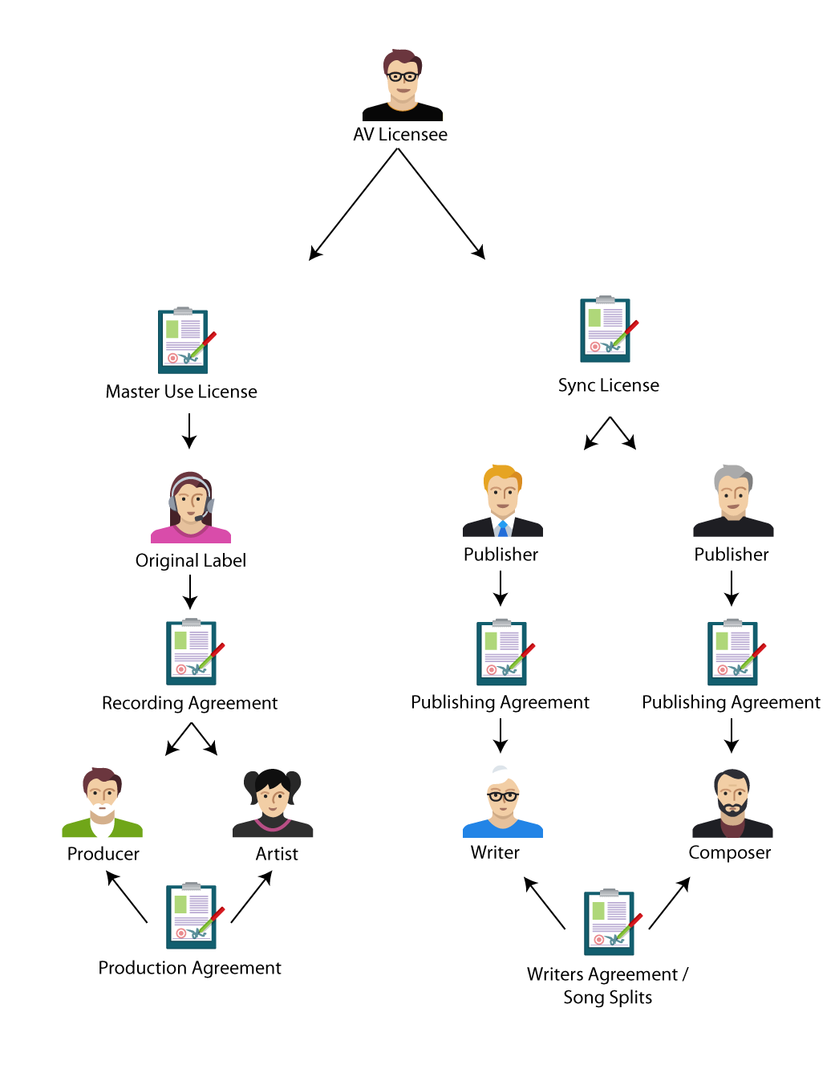

Traditional food chain for licensing

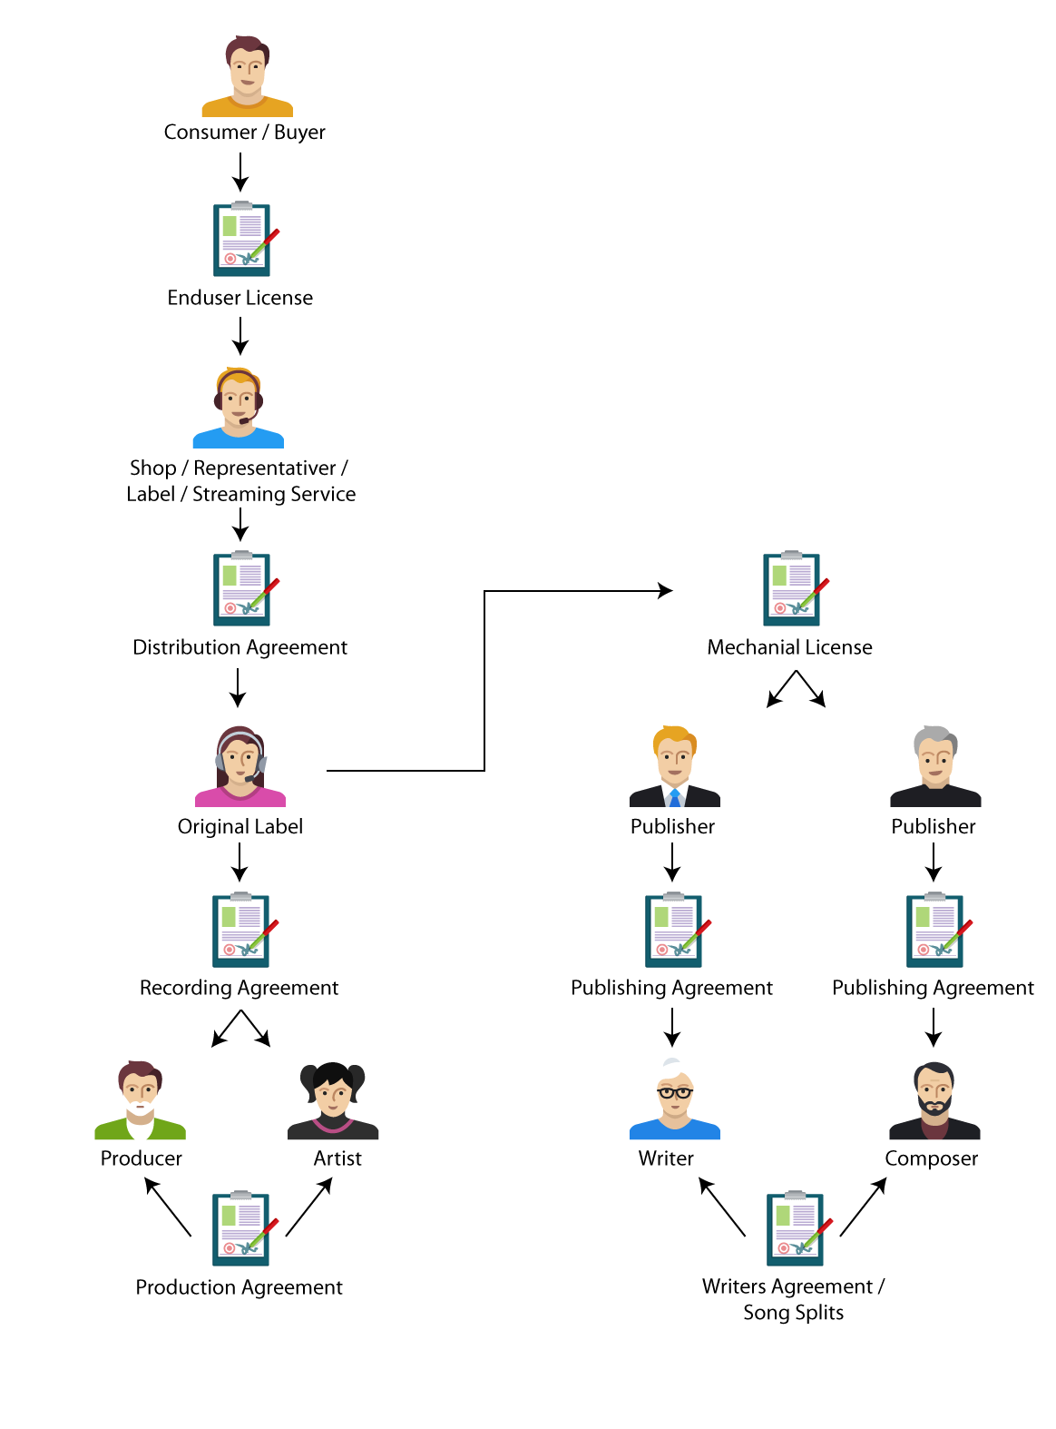

The traditional food chain for ‘record’ sales

# Goals

## Content Delivery for Pre-Cleared Music

DigiRAMP offers an API and a SDK that enables third parties to effortless interact with the DigiRAMP backend.

They can:

* Use streams together with their services e.g. Devices. Games and Services.
* Integrate with existing frontends.
* Clear and pay for existing content
* Embed a personal DigiRAMP shop as a snippet

## Integrate Rights, and Media with Administration

DigiRAMP provides unique tools needed for managing the rights as required by the law and practiced by the industry. This enables all parties to benefit from cutting the costs by creating a direct gateway between consumers and creators. DigiRAMP is in no way changing the way the industry is working but are providing an option to create virtual middlemen’s so revenue from consumers to creators can flow directly with a minimum of players and administration involved

## Cut costs by Automation and real-time micro transactions

DigiRAMP can manage and distribute payments to all stakeholders in real-time. This way there is full transparency and stakeholders can monetize the real value of content.

All stakeholders can be confident that the revenue reaches the right hands and there is no delay.

## Promote Artists and Content directly to consumers

Creators have the biggest interest in reaching their fans. Promotion is done true social media and typical by the artists themselves. None of the existing social network respects and pays the artists directly. DigiRAMP do not try to replace the existing players but offers an alternative dedicated to artists and creator that integrate with the existing players and makes it easy for fans and supporter’s to help spreading the word in the cloud.

# Roadmap / Strategy

## Users and Content

DigiRAMP is not an exclusive club for the few. A lot of great content exists and are collected in catalogs owned and controlled by individuals Indi labels and big labels. How hard it is to satisfy their needs are can be listed like this

1. Individuals (easy)
2. Indie labels (medium)
3. Big labels (hard)

Growing a user base is tightly connected to getting content from individuals and indie labels. When a threshold is reached bigger labels could also have an interest in reaching the user base. If there is a sound base of third parties users of the API this would be a Win. Win. Win situation.

## Legal protection

Patent on Database Model

Patent on Workflows

## Technology readiness

Scale servers

Shift from rails to Erlang

Proprietary Storage?

Super great embeddable music player

Integrate with DAW’s

API for third parties

# Production and Creation

* Producers
* Artists
* Writers
* Studios

Revenue of record production 2008 - 2020

Goes from 353 to 653 million

With projected inflation on 2%

653 * (0.98 ^12 ) = 512 mill USD and gives a 45% growth over 12 years or 3.75 a year

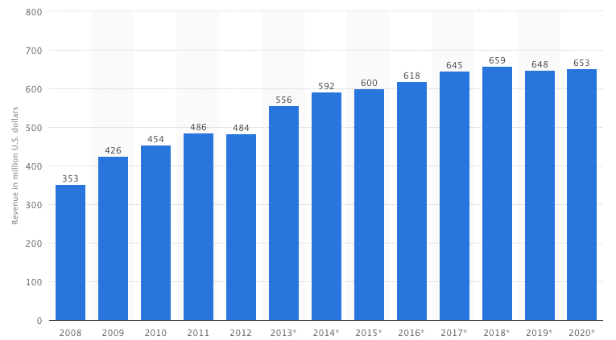

# Publishing and Rights owners

* Performance rights organizations
* Major labels
* Minor labels
* Indie labels

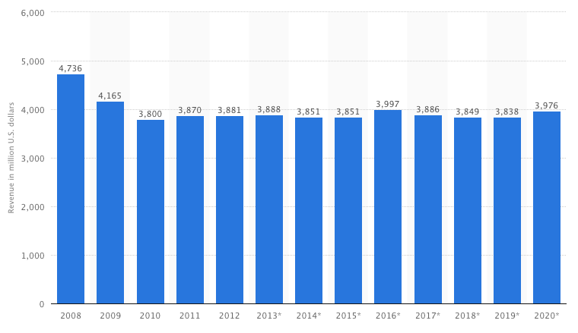

## Universal Music Group

<https://www.crunchbase.com/organization/universal-music-group#/entity>

HQ in Santa Monica

Founded February 1981

Employees: 5k – 10k

# Distribution

* Physical media
* MP3 downloads
* Streaming services

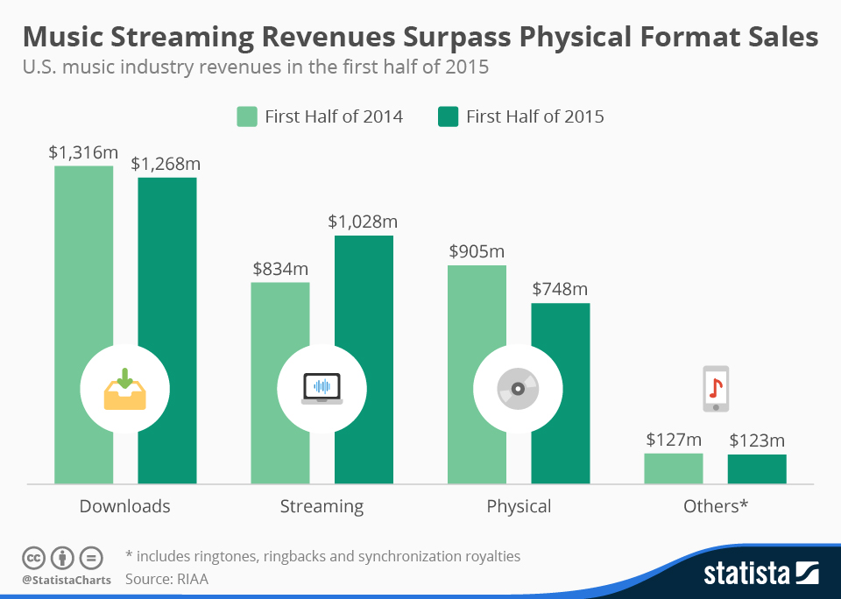

# Case studies indie labels

DIY Indie labels 1,067 in us according to Wikipedia

Notable labels world +600 estimate based on Wikipedia

## Glassnote

<http://glassnotemusic.com/>

* Signed 20 bands.
* Distribute true iTunes and Amazon
* Live events and tickets sales

## Loudr

<https://loudr.fm/>

<https://www.crunchbase.com/organization/loudr#/entity>

Licensing, distribution and rights

* Distribute true established services iTunes Spodify etc..
* Download of mp3
* Song splits

Founded February 2013

Founding 200k + 400k

Team 4 personas

Key numbers -Missing

# Streaming services

## Spotify 2014

<https://www.crunchbase.com/organization/spotify#/entity/>

* Registered in Luxenburg
* Active in 58 countries
* Turnover 756,9 EURO
* 74% growth since 2013
* 91% income from subscriptions 9% from ads
* 52 personas in current team
* Funding $1.06B in 11 Rounds from 31 Investors

## Pandora Media

<https://www.crunchbase.com/organization/pandora#/entity>

* Team 26 Personas
* Funding Rounds (6) - $56.3M
* Revenue $311.6 million.
* Active listeners 78.1 million,

## Apple Music

* 6.5 million paying customers
* 15 million users total.

Key numbers –Missing

## SoundCloud

<https://www.unternehmensregister.de/ureg/result.html;jsessionid=B60083B5472FE435DFFF128877F55D4B.web03-1>

<https://www.crunchbase.com/organization/soundcloud#/entity>

* 350 mill monthly users
* 15 in current team
* Founding 123.32M in 5 Rounds from 9 Investors

# Aggregators

Digital Music Aggregators offer service for content owners to upload their music and then deliver their music to other DSP's for commercial use. i.e. spotify. Apple music amazon Google Pandora music etc…

## TuneCore

<https://www.crunchbase.com/organization/tunecore#/entity>

<http://www.privco.com/private-company/reverbnation>

TuneCore is a digital music distribution platform for artists to sell their music on iTunes, Amazon, Spotify and Rdio.

## Reverbnation

<https://www.crunchbase.com/organization/reverbnation#/entity>

Funding: $8.6M in 3 Rounds from 3 Investors

Fair usage license

Band camp